Using ELC to model the parameters of Binary System SV Cam

Jay Franck
San Diego State University
Submitted: 09 December 2010

Abstract

The binary star system SV Cam is modeled using the ELC Fortran code. The parameters are optimized in a genetic algorithm with B,V,R photometry and radial velocity data from both stars as input. The ELC program then generates ligh/radial velocity curves based on these optimized parameters. These curves are then plotted with the folded data sets, and compared with published light curves. The optimized parameters are also analyzed and compared with published data. The binary SV Cam is calculated to be a 0.59 day orbit of a F9 and K4 primary and secondary star, where the primary star has a large number of spots dispersed over the surface of the star. The binary is in a detached system, with each star far from filling its Roche Lobe. The mass ratio of the system was calculated to be 0.640, in an approximately circular orbit and inclination of 90°.

I. Introduction

There is renewed interest in the binary system SV Cam from numerous teams attempting to model this strange system. Jeffers et al. published three papers in 2006 concerning SV Cam: Dense Spot Coverage and Polar Caps on SV Cam, as well as Part I and II of Hubble Space Telescope observations of SV Cam (which now will be referred to as Jeffers et al. 2006a,2005,2006b, respectively). Rucinski et al. published a number of radial velocities for interesting close binaries in 2002 which contained SV Cam, while Milone et al. (2005) used the binary’s orbital parameters as a hypothetical benchmark for refinement by future Gaia observations.
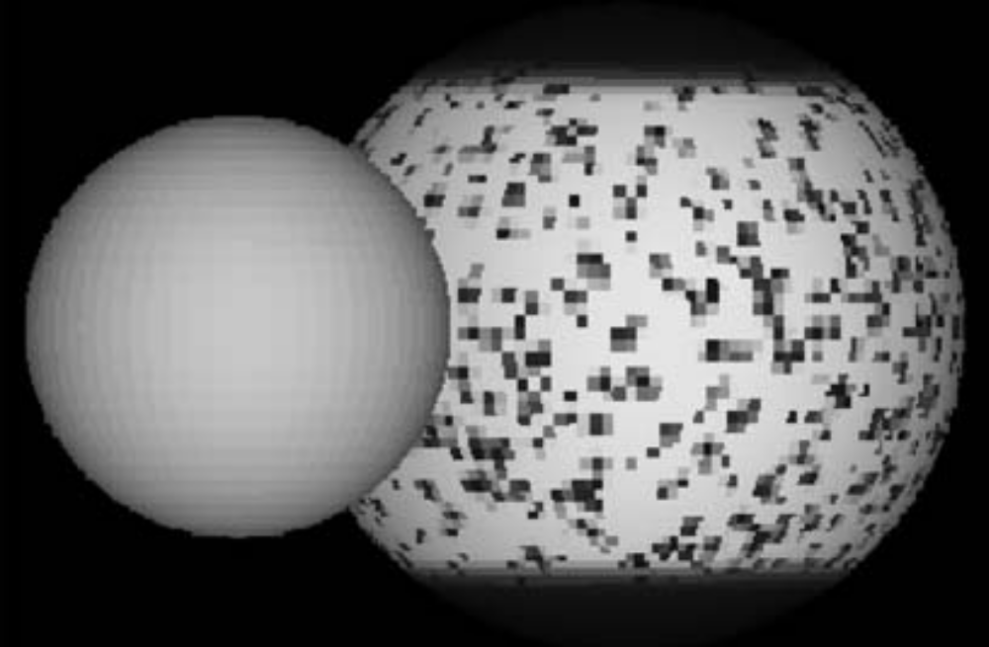
Figure 1: Jeffers et al. 2006a use an eclipse mapping code to produce a large number of spots that would fit observed light curves, and built a synthetic image of the star based on this. Notice the secondary star lacks such spots in this model. 28% of the luminous surface is covered in spots.
SV Cam is an interesting binary in that it is a detached system with a relatively short period of 0.59 days, F9 main sequence primary, K4 main sequence secondary, and most interestingly, the primary has been found to be covered in a large number of sun spots across its face, and possibly two large spots on each of its poles (Jeffers et al. 2006a,2006b). Previously, the light curve of this object had been difficult to explain, as well as the determination of the spectral types and effective temperatures of the system. Figure 1 is a simulated image produced by Jeffers et al. (2006a) as a representation of the primary star.

The aforementioned papers were used as a guide for the orbital parameters that were optimized by ELC’s Genetic Algorithm. Data sets of U,B,V, and both radial velocities were provided with estimated errors, and these were input into the Genetic Algorithm. The ELC.inp file was also adjusted in some ways before Genetic was run. Genetic provided χ² values, optimized values, and folded data sets from the input data after 2-3 days of run time.

II. Program Specifics

A total of two successful iterations of ELC were performed. The literature on SV Cam contained a large number of the parameters of the binary system, but was lacking in certain key aspects. For this reason, the first instance the genetic algorithm was run ignored the possibility of spots on the star. This was done primarily to get the motions, masses, and other important factors constrained that did not depend on the presence of spots or not. ELC can only optimize a total of 16 parameters, so the optimization of SV Cam had to be performed in multiple steps.

The first iteration included the modification of the ELC.inp file to the information provided primarily by Jeffers et al. 2005,2006a,2006b. Table 1 contains a list of the orbital parameters changed in ELC.inp from the data in the Jeffers et al. papers (primarily 2006b, but there is significant overlap of the papers).

Radius Primary | 1.235±0.003
Period | 0.59 days
T1 | 5973±31 K
T2 | 4831±103 K
Radius Secondary | 0.727±0.003
Table 1: A compilation of data found by Jeffers et al. 2005,2006a,2006b for the binary SV Cam. These values were input into the ELC.inp file, as well as the optimization input file gridloop.opt for use by geneticELC. Units of the radii are listed in units R_{sun}

Jeffers et al. 2006b paper was also instrumental in determining a few other parameters (with the help of the ELC manual). Based on the spectral types F9+K4 (implying convective envelopes), the parameters Tgrav1,2 were set to 0.08, and alb1,2 were set to0.5 in the ELC.inp file. Likewise, fill1 and fill2 were changed to 0.5 to represent the fact that these stars are not filling their Roche Lobes, as the system is classified as a detached binary.

Rucinski et al. 2002 is a published list of radial velocities for a variety of systems, and the initial values used from this paper are included in Table 2.

K1 | 121.86 ± 0.76
K2 | 190.17 ± 1.73
Systemic Radial Velocity | -9.31±0.78
Table 2: The collection of velocity values determined by Rucinski et al. 2002 which were used as starting parameters of ELC.inp. All the values listed and their associated errors are listed in km/s. K1,2 are the velocity amplitudes of the primary and secondary, respectively.

From Lehmann et al. 2002, the mass ratio q = 0.642 and the inclination = 90° were used in both the gridloop.opt file for the genetic algorithm, as well as inputs into ELC.inp. The mass ratio value was confirmed by Rucinski et al. 2002, but no other journal included the value of the inclination of the system. The only paper to include an initial guess of the eccentricity was Milone et al. 2005, where e=0.0.

From the collection of these values, a few of the following inputs were calculated by hand: The ratio of radii (ratrad) = 1.699, the temperature ratio T2/T1 = 0.8088, and the mass function (fm) = 0.1106. A number of values in the ELC.inp file were intentionally left blank or given a negative value, flagging it to be ignored. An example of this would be any value associated with a secondary accretion disk.

Using these values as a base, min/max values based roughly on the errors of the values provided by other authors, geneticELC was run to optimize a total of 13 values with a population of 100 and 400 generations. For the readers convenience, the parameters are appended to this document as gridloop.opt.first.

The results from this first execution of the genetic algorithm are listed in Table 3. The output results are appended to this document as SVCam.jay for the readers convenience. Of particular note are the χ² values associated with each of the inputs (B,V,R,RadVel1,RadVel2), which are as follows:
chiB= 306.1250, chiV= 289.5249, chiR= 213.4386, chiRV1= 14.08, and chiRV2= 98.11. These will be investigated further in Section IV: Conclusion and Discussion.

q (mass ratio) | 0.640
fi1(Fill1) | 0.4972160
fi2(Fill2) | 0.4832670
separation(in R_{sun}) | 3.6577
Period | 0.592854000 days
argper(Argument of Periastron ω) | 276.499°
Teff1 | 5900.00 K
Teff2 | 4773.10 K
To | 50731.290910 days
eccentricity | 0.0000
al1(Albedo of Star1) | 0.44080
al2 | 0.40000
gam1 | -59.1770 km/s
gam2 | -58.9491
inclination | 90.000°
Total χ² | 921.278083
Table 3: Initial geneticELC results from the parameter file gridloop.opt.first. This data set represents the values that were used in the second execution of the genetic algorithm, which focused primarily on the values associated with spots on the primary star. The total χ² value associated with this fit was 921.278083

Using the file gridELC.inp as the first optimized version of ELC.inp, a new gridloop.opt file was constructed for the second and final iteration of the geneticELC algorithm. As mentioned previously, the focus of this optimization would be too determine the temperatures, locations, and angular sizes of the spots on the primary star. ELC allows for two spots to be optimized on each star, but since there are assumed to be a large number of spots on the primary, a wide range of values were utilized in the paramater file. The temperature coefficient was constrained to be between 0 and 1 for both spots, since the spots are assumed to be cool (i.e. dark) spots, and not hotspots on the star. The angular size, latitude, and longitude for each spot was constrained between 0° and 360°, allowing the program a full range of possibilities and accounting for the problem of only two spots to be modeled. As before, the parameter file is appended to this document for the reader's benefit as gridloop.opt.second.

A total of 16 variables were set to be optimized. Some of these values had previously been optimized in the first iteration, but did not have the benefit of the possibility of spots being present on the star. Therefore, they were also included. A complete list of values that were optimized are listed in Section III. Results, as well as in the appended input file gridloop.opt.second.

III. Results

After approximately 3 days of computing time, the results from the second iteration of the geneticELC were complete. The results are listed in Table 4 below. The output results are appended to this document as SVCam2.jay

Mass Ratio (q) | 0.64000000
Fill1(fi1) | 0.4972160
Fill2(fi2) | 0.4832670
separation(sep) | 3.6577
Period | 0.5928540 days
argper(Argument of Periastron ω) | 276.499°
Teff1 | 5900.00 K
Teff2 | 4773.10 K
Temperature Factor Spot 1 | 0.7994
Temperature Factor Spot 2 | 0.7509
Latitude Spot 1 | 100.99°
Latitude Spot 2 | 29.664°
Longitude Spot 1 | 335.85°
Longitude Spot 2 | 127.22°
Radius Spot 1 | 29.664°
Radius Spot 2 | 146.419°
Gamma for the RV of primary(gam1) | -56.9034 km/s
Gamma for the RV of secondary(gam2) | -63.0004 km/s
Total χ² | 1089.947991
Table 4: Optimized values from the second iteration of geneticELC. Some points of interest are the angular size of the spots, the fact that the Total χ² value of this iteration is greater than the first iteration, and the relatively unchanged first eight paramters in the list from the first iteration. These will be discussed in detail later in the paper.

As in the first execution of genetic, there is valuable information in the χ² values of each of the inputs. This is the list of values for the second execution (with spots): chiB= 353.5924, chiV=242.8649, chiR=253.0089, chiRV1=46.22, and chiRV2= 194.26. Comparison of these values with those of the first genetic values (no spots) will be in Section IV. Conclusions and Discussion.

The values listed in Table 4 (as well as some values in Table 3) were input into ELC.inp and synthetic light and radial velocity curves were generated. The outputs in linear units (modelV.linear in this case) were then run with the folded input data from genetic in the program checkfit.for. This produced a file model.out, which was a synthetic lightcurve in phase with the folded data. The plot of the output is shown in Figure 2. The light curves in B and R have the same general shape, but have larger χ² values and are therefore omitted from this paper.
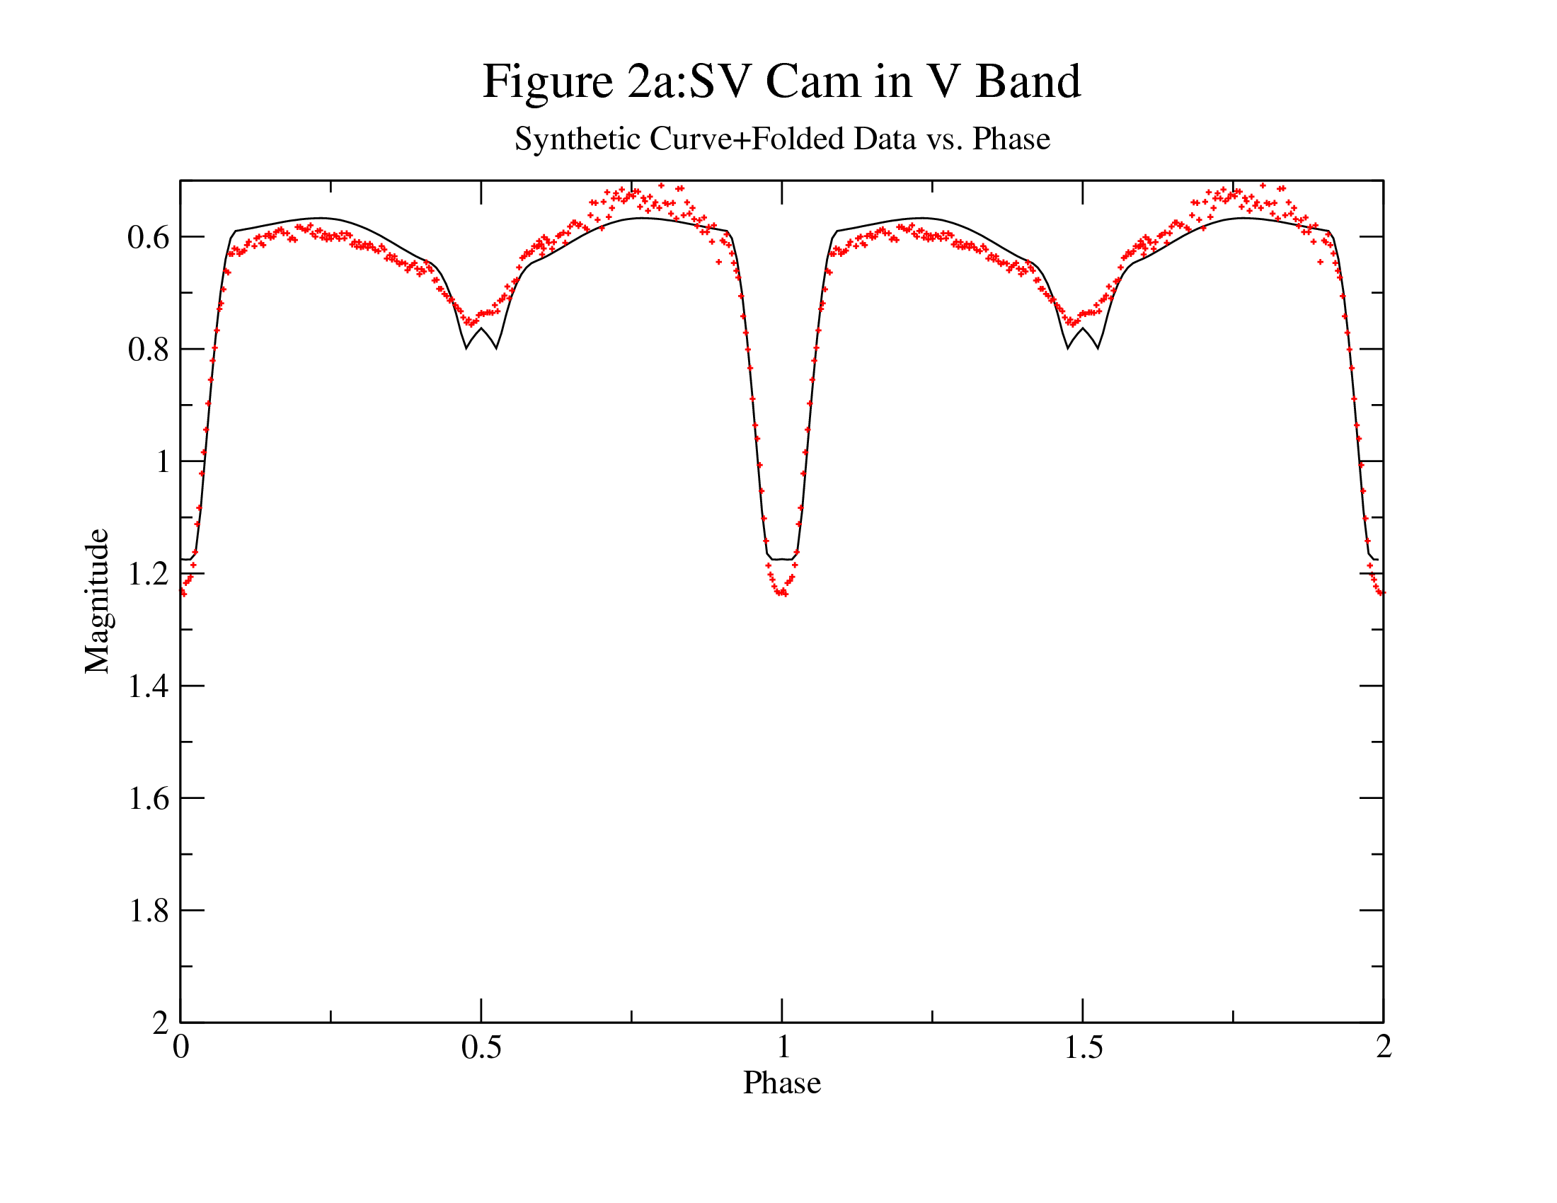
Figure 2: This is the synthetic V Band light curve of SV Cam. The dots are the folded observed values of SV Cam in the V Band. There seems to be a decent overall fit to the star, except at the bottom of the primary and secondary eclipses, and there is an obvious deviation (with considerable scatter) after the secondary eclipse in the region of phase 0.75. Some of this scatter must be due to the presence of a vast number of spots.

The radial velocity curve was produced for both the primary and secondary stars, and the same method of using the folded data and checkfit.for to produce a light curve plot was used for the radial velocities. However, in the case of the radial velocity measurements, a correction for the Systemic Velocity (γ) of had to be accounted for, and a Data Transformation was implemented in xmgrace to shift the data by the systemic velocity. When geneticELC was run, it included the gamma corrections as part of its output file, and these were added to the velocity curves. The curves (Figures 3 and 4) generally have a good fit with the data, and the reader can refer to the χ² values above to confirm this numerically.
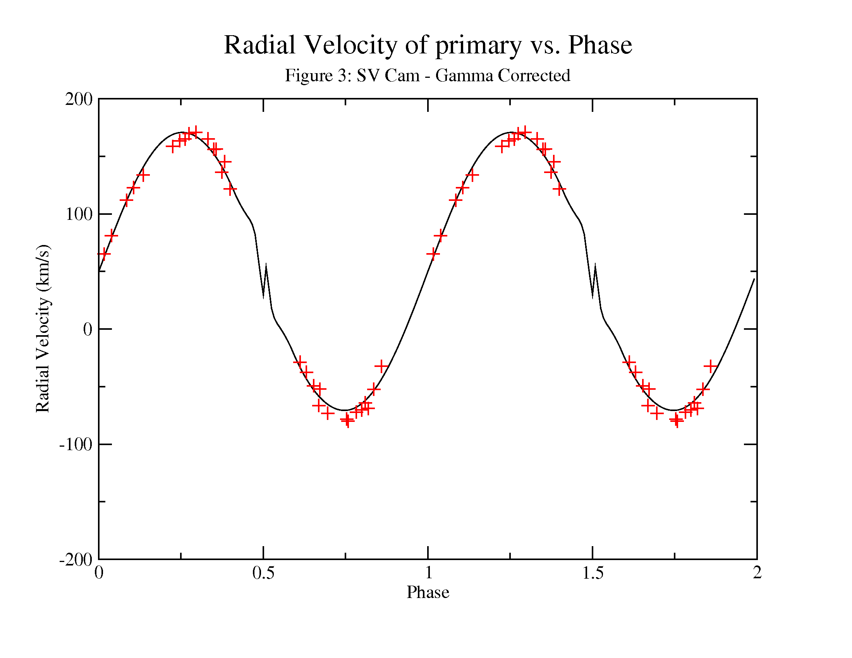
Figure 3: The synthetic radial velocity line for the primary seems to fit the 'plus' signs that represent the folded radial velocity values for the primary. However, the spikes at phase 0.5 and 1.5 are worrisome. An increase in the Nalpha and Nbeta values (resolution of the fit) did not seem to have any difference on the presence of the spikes. A more complete list of observations would have been helpful in this instance. The gamma value for the primary was -56.9034 km/s.
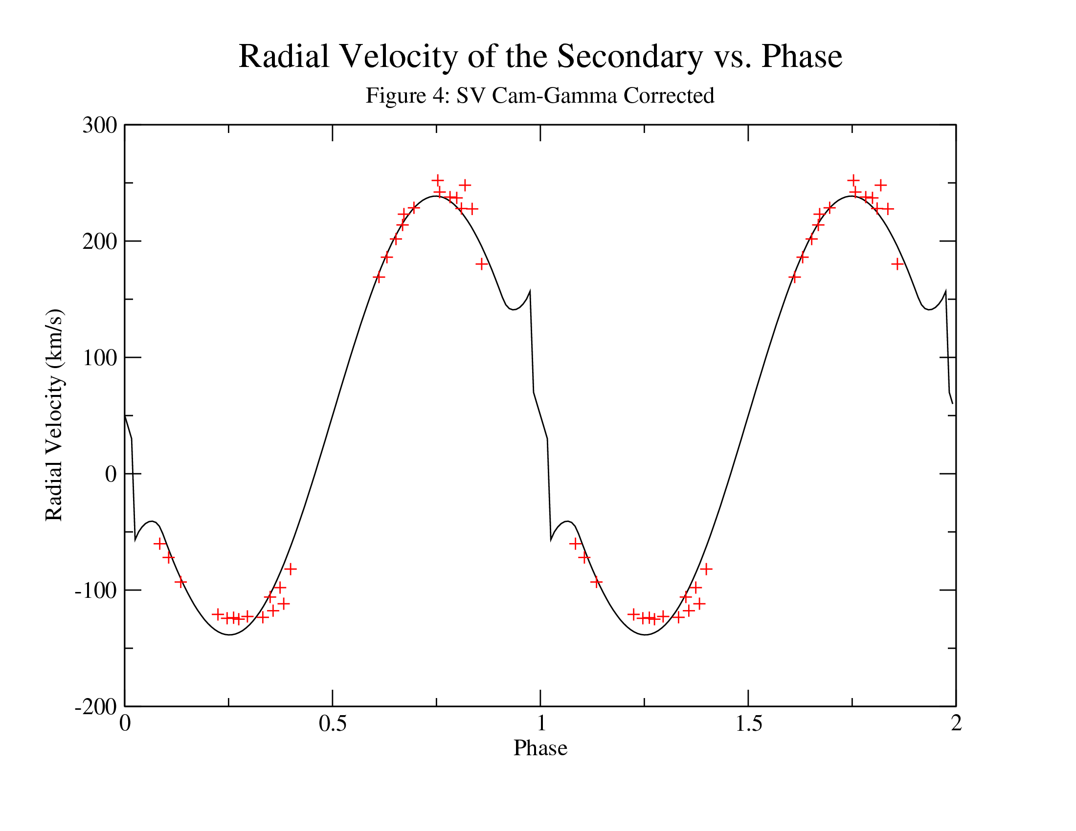
Figure 4: The radial velocity curve of the secondary star appears even more strange than that of the primary star. There are two hook-like protrusions in quick succession near a phase 1. Without data points in this region, it is difficult to comment analytically on these. However, these are most likely the result of some error in input parameters, as there is no justification for a punctuated change from a decreasing radial velocity to an increasing velocity in such a short phase. The gamma value for this star was found to be -63.0004 km/s.

IV. Conclusions and Discussion

Analyzing the output and the plots of ELC's version of SV Cam, for the most part, has been quite consistent with the values proposed by Jeffers et al., Rucinski et al., Milone et al. and Lehmann et al. The light curve that was produced by Jeffers et al. 2005 using HST data can be seen in Figure 5. A visual comparison of this light curve compared to the Figure 2 light curve is extremely similar. A key feature that both data sets have some strange scatter pattern around phase 0.75. This has probably something to do with the large number of spots on the primary, which introduces this variability in the data.

The ELC light curve produces an 'W' shape at the bottom of the secondary eclipse, which neither the data nor the published light curves represented. This could have been from the method in which the ELC code distributed the spot 1 and 2 onto the surface of the star. Since the spots are not evenly spread out on the surface of the star, and spot 1 and 2 are quite large with respect to the star (~29° and ~146°). If the small part of the star not obscured by a spot turned to face the observer at the point of secondary eclipse, there could be an increase in the magnitude. However, since this model is not supported by any data really, it is most likely a fabrication of the model, and not a model of reality.

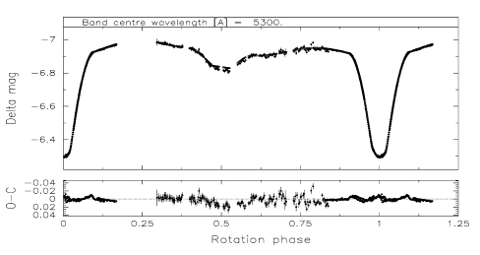

Figure 4: Visual light band curve produced by Jeffers et al. 2005 overlaid with HST data of SV Cam. It is important to note that there is similar scatter of data around phase 0.75 as the data used in this paper. However, it appears that the Jeffers et al. fit is much better than the ELC fit provided in this paper.

A further examination of the primary's spots are necessary for understanding some of the errors in the light curve. Obviously, based on the premise adopted by Jeffers et al. 2006a with their determination of a large number of spots speckling the surface of the star (see Figure 1 as a reference), ELC's approximation of only two spots for the entire system may be a large problem in modeling this star. From ELC's determination that the spots were 29.664° and 146.419°, it is easy to see that there must be a large number of spots on the system, but in order to model this with only two spots, these spots must be made extra large. If it is also true that there are two dark caps on the primary's poles, the difficulty ELC has optimizing the spots is compounded.

The radial velocity fits, as mentioned before, contain the strange 'spikes' where the curves slope changes sign with no justification. Increasing the resolution (Nalpha from 40 to 60, Nbeta 16 to 20) of ELC in the hopes that these spikes would be washed out did not change at all. Without a physical justification of these spikes, the assumption is that the input of parameters into ELC must have been in error to produce such velocity curves.

Comparing the values from Tables 1 and 2 (which were from recent papers from a variety of teams) to Table 4 (final output from ELC), the values of the parameters changed insignificantly, and many of the initial parameters did not change at all (or converged to the values found by Jeffers et al 2005, 2006a,2006b). A few examples that changed insignificantly are listed in Table 5. The main deviation from published results was the temperature of the primary star. This is not surprising since the previously discussed spots on the primary star would have serious implications in the modeling of the surface temperature of that star. If the model for the spots is different, obviously the model for the temperature will also be different.

Parameter | Value from* Jeffers et al 2005, 2006a,2006b | Computed Value
T1 | 5973±31 K | 5900.00 K
T2 | 4831±103 K | 4773.10 K
Mass Ratio (q) | q = 0.642 | 0.6400
Table 5: The values of T1,T2, and the mass ratio were the parameters that changed the most of all the values optimized. Notice that the Temperatures are quite close to the published values, and T2 falls within the errors of the published values. *The mass ratio published value is from Lehmann et al. 2002, but was cited in Jeffers et al. 2006b.

The published spectral types (Jeffers et al. 2006b) of the stars of F9 primary and K4 secondary do seem to be modeled well. The initial parameters of the separation, Roche Lobe filling fit the general sizes of the stars, the mass ratio does not seem unreasonable considering a F9 star is not ten times larger than a K4 star, for example. The temperatures 5900K and 4773K generally fit a ~G0 star and a ~K5 star, respectively.

With some concessions, the parameters and light and radial velocity curves generated by ELC were able to satisfactorily model SV Cam. Without the benefit of a more precise way to handle spots on the primary star, the optimizer was able to make a reasonable approximation that agreed with conventional published data for the system. With more computer time, it is quite probable that the 'spikes' shown in both radial velocity curves would be smoothed out.

References

Jeffers, S.V.; Barnes,J.R.; Cameron, A. Collier; Donati,J.-F. 2005 RAS, MNRAS 366, 667–674

Jeffers, S. V.; Cameron, A. Collier; Barnes, J. R.; Aufdenberg, J. P. Astrophysics and Space Science, Volume 304, Issue 1-4, pp. 371-373. 2006
Jeffers,S.V.; Barnes,J.R.; Cameron,A.Collier; Donati,J.-F. MNRAS 367, 1308–1316 2006

Lehmann H., Hempelmann A., Wolter U., 2002, A&A,392,963.

Milone, E.F. U. Munari, P.M. Marrese, M.D. Williams, T. Zwitter, J. Kallrath, T. Tomov, 2005 arXiv:astro-ph/0506106v1

Orosz, J. A., & Hauschildt, P.H. 200, A&A, 364, 265

Rucinski,Slavek M.; Lu,Wenxian; Capobianco,Christopher,C.; Mochnacki,Stefan W.; Blake, R.Melvin; Thomson,J.R.; Ogłoza,Waldemar; Stachowski, Greg. AJ 124:1738–1745, 2002

